In This Issue
POLICY WATCH – May 2022

- Message to New Grads: Life is for Service
- Two Nuggets from Commencement Speeches
- Gen Z Workers Crave Career Stability
- Bank of America is NBLC’s Newest Board Member
- North Bay Leaders Were Honored on May 13th – Thank you to our Sponsors!
- Members in the News
This issue of Policy Watch was drafted just prior to the horrific slaughter of innocent children in Uvalde, Texas. We must not allow ourselves to become numb to this accumulation of senseless tragedies. No one has articulated the need for us to turn grief and outrage into action better than Golden State Warriors head coach Steve Kerr:

https://www.youtube.com/watch?v=Q5x4eHn_3tA
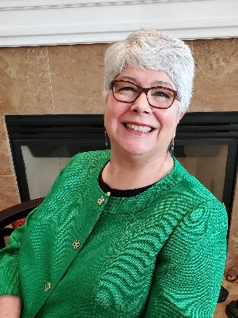
In this issue, we look at what’s on the minds of our new graduates and what they are looking for in their first jobs. It appears Gen Z has different goals and desires than previous generations. They crave career stability and want flexibility to achieve a positive work/life balance. A quarter of them want to be paid in cryptocurrency! Read on for more revelations.

NBLC welcomes Bank of America to our Board of Directors and Jason Foster, the President for Bank of America in Napa, Marin & Sonoma, as the board member. And NBLC was proud to honor the Leaders of the North Bay this month and is grateful to the sponsors who made our event a success. And if you missed hearing our keynote speaker, teen Hollis Belger, read on for a second chance to hear her speech!

It is also in May that we reached the horrible milestone of 1,000,000 dead from COVID. And as we experience another surge, we must mark this moment and grieve those we have lost. This poem spoke to me:

Watching My Friend Pretend Her Heart Isn’t Breaking by Rosemerry Wahtola Trommer

On Earth, just a teaspoon of neutron star
would weigh six billion tons. Six billion tons
equals the collective weight of every animal
on earth. Including the insects. Times three.

Six billion tons sounds impossible
until I consider how it is to swallow grief –
just a teaspoon and one might as well consumed
a neutron star. How dense it is,
how it carries inside it the memory of collapse.
How difficult it is to move then.
How impossible to believe that anything
could lift that weight.

There are many reasons to treat each other
with great tenderness. One is
the sheer miracle that we are here together
on a planet surrounded by dying stars.
One is that we cannot see what,
anyone else has swallowed.

Be kind and be safe.

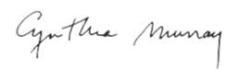
Best,

Cynthia

Message to New Grads: Life is for Service

In this issue we are celebrating and listening to the graduates of 2022. These graduates have a lot to say, and we can learn from them as we look at the workforce and our leaders of this generation. We start with the uplifting speech of Rollins College valedictorian Elizabeth Bonker ’22, who is affected by non-speaking autism and communicates solely by typing, urges her fellow graduates to use their voices, serve others, and see the value in everyone they meet. Here are excerpts from her Valedictorian speech (Link):

“Rollins College class of 2022, today we celebrate our shared achievements. I know something about shared achievements because I am affected by a form of autism that doesn’t allow me to speak. My neuromotor issues also prevent me from tying my shoes or buttoning a shirt without assistance. I have typed this speech with one finger with a communication partner holding a keyboard. I am one of the lucky few non-speaking autistics who have been taught to type. That one critical intervention unlocked my mind from its silent cage, enabling me to communicate and to be educated like my hero Helen Keller.”

“During my freshman year, I remember hearing a story about our favorite alumnus, Mister Rogers. When he died, a handwritten note was found in his wallet. It said, “Life is for service.” You have probably seen it on the plaque by Strong Hall. Life is for service. So simple, yet so profound.”

“Viktor Frankl wrote about the power of sharing in his book, Man’s Search for Meaning. While suffering in the Nazi concentration camp at Auschwitz, he noted how, despite the horror, there were prisoners who shared their last crust of bread. He writes, ‘Everything can be taken from a man but one thing: the last of the human freedoms—to choose one’s attitude in any given set of circumstances, to choose one’s own way.’”

“The freedom to choose our own way is our fundamental human right, and it is a right worth defending, not just for us, but for every human being.”

“Whatever our life choices, each and every one of us can live a life of service—to our families, to our communities, and to the world. And the world can’t wait to see our light shine.”

“So, my call to action today is simple. Tear off a small piece from your commencement program and write ‘Life is for service’ on it. Yes. We gave you the pens to really do it. Let’s start a new tradition. Take a photo and post it on social media. Then put it in your wallet or some other safe place, just as Mr. Rogers did.”

“We are all called to serve, as an everyday act of humility, as a habit of mind. To see the worth in every person we serve. To strive to follow the example of those who chose to share their last crust of bread. For to whom much is given, much is expected.”

“God gave you a voice. Use it. And no, the irony of a non-speaking autistic encouraging you to use your voice is not lost on me. Because if you can see the worth in me, then you can see the worth in everyone you meet.”

“My fellow classmates, I leave you today with a quote from Alan Turing, who broke the Nazi encryption code to help win World War II. ‘Sometimes, it is the people no one imagines anything of who do the things no one can imagine.’”

“Be those people. Be the light! Fiat lux. Thank you.”

Two Notable Commencement Speeches this Year

From an article titled, The Most Notable Commencement Speeches of 2022 (Link), we get two good nuggets of advice to the graduates:

Ken Burns, University of Pennsylvania:
Fresh off his new series on Benjamin Franklin, Penn's founder, the award-winning documentary filmmaker urged graduates not to focus on amassing "Benjamins."

Favorite Quote: "We've nearly broken this Republic of ours, but somehow you've got to fix it. You're going to have to initiate a new movement, a new Union Army, that must be dedicated above all else — including your career and personal advancement — to the preservation of this country's civic ideals. You'll have to learn, and then re-teach the rest of us that equality — real equality — is the hallmark and birthright of all Americans."

Taylor Swift, New York University
The internet blew up when NYU announced Taylor Swift would be this year's commencement speaker and receive an honorary degree. Telling stories about her triumphs and travails, Swift told graduates to learn from mistakes and stay resilient because "life can be heavy, especially if you try to carry it all at once."

Favorite Quote: "In your life, you will inevitably misspeak, trust the wrong person, underreact, overreact, hurt the people who didn't deserve it, overthink, not think at all, self-sabotage, create a reality where only your experience exists, ruin perfectly good moments for yourself and others, deny any wrongdoing, not take the steps to make it right, feel very guilty, let the guilt eat at you, hit rock bottom, finally address the pain you caused, try to do better next time, rinse, repeat."

Gen Z Workers Crave Career Stability

Building on looking at our incoming workforce, we have some new studies that shines a light on what our newest workers seek in the jobs. In Gen Z Workers Crave Career Stability by Hope King, author of Axios Closer (Link), we learn new information that signals a sea change in what employees want in their jobs and from their employers. The big take-away is that younger workers don’t want to job hop, they are looking for stability. And one of the key benefits they seek is mental health support, something that has been lacking from many employers. And about a quarter of them want to be paid in cryptocurrency!

King says, “Younger workers, in the aftermath of the pandemic, are craving a more traditional work experience with employers who accept them for who they are.” Here’s her breakdown of that data:

Why it matters: Companies across industries are trying to figure out the right way to meet employees' new needs — such as hybrid work requirements and benefits — amid a labor market that still favors workers.

State of play: Among recent grads, mental health support is the top career expectation, according to a new survey of 1,000 young adults from iCIMS, a talent acquisition software provider.
- 91% of those surveyed (class of 2020, 2021 or 2021 undergrads) said they care how long they stay with an employer.
- Nearly 70% say they actually see themselves staying long term.

The big picture: The upheaval that graduating college students have lived through over the past three years has changed their perspective on what they want and need.
- “Stability is key for them,” Rhea Moss, director of data insights and customer intelligence at iCIMS, tells Axios.

What to watch: Younger workers are diligent about researching the companies they work for as well as their potential managers, according to the study.
- "[This generation] is being very particular about the company they'd want to work for where they feel that they can bring their whole, true self to work," says Moss.
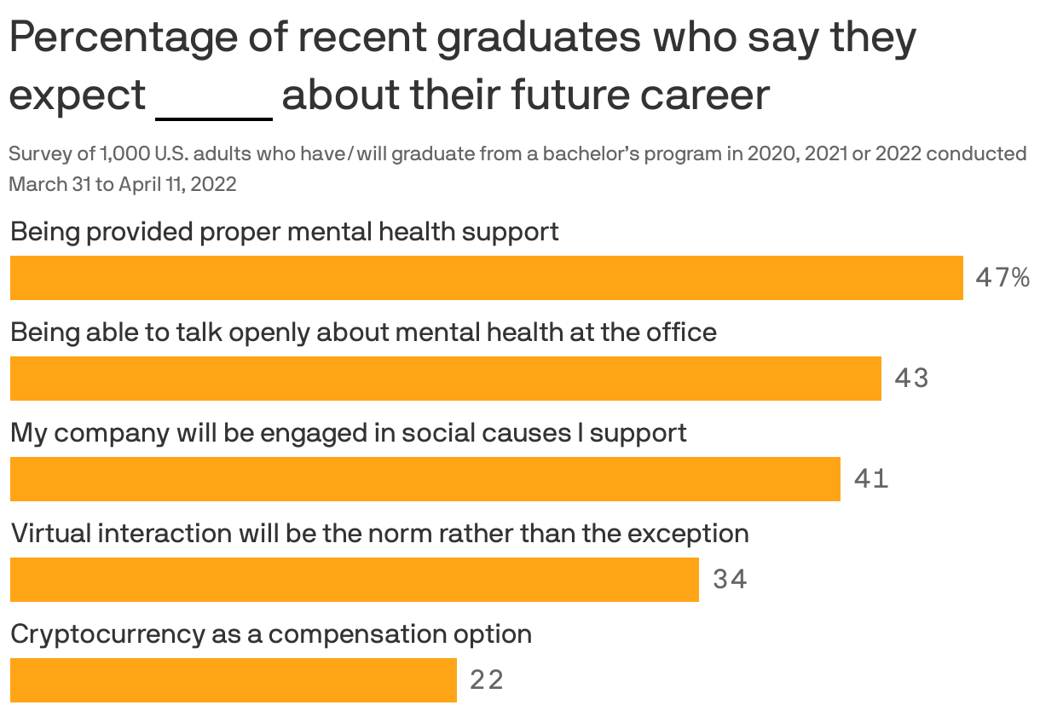
Link to Graph
Data: WakeField via iCIMS Class of COVID-19 report; Chart: Jacque Schrag/Axios

In Gen Z doesn’t want to go back to the office without these 3 things by Diana Shi (Link), we learn of another study. “Santor Nishizaki, coauthor of the upcoming Working with Gen Z: A Handbook to Recruit, Retain, and Reimagine the Future Workforce after COVID-19, has done research on the youngest cohort of workers, and the pandemic has had significant psychological effects on young people. ‘Half of the working Gen-Zers we surveyed stated that working remotely increased their level of anxiety and depression. More than half admitted to having the feeling of increased loneliness and a more challenging time dealing with conflict since going remote.’”

Shi says, “So, if you’re asking employees (of any generation) to return to in-person work, see what you can do to encourage opportunities for collaboration and connection. According to research from Indeed, 73% of workers reported they missed socializing with their coworkers while 45% shared they missed in-person meetings.”

The next thing Gen Z workers want is flexibility. Shi says, “Look at any study about what workers care about, and you’ll see that white-collar employees want more flexibility to get things done when and where they want. So it makes sense that this benefit looms large in Gen Z’s minds, as well. Microsoft’s research notes that Gen Z is 77% more likely to interact with a job posting on LinkedIn if it includes the word ‘flexibility.’ That’s higher than for all other generations, including millennials, who were a mere 30% more likely to interact.”

Shelley Hernandez, a university recruiter at Pinterest, says Gen Z’s willingness to voice their support for less-traditional working styles is refreshing. “This generation really understands that their preferences may not necessarily be their colleagues’ preferences, and they are advocating for companies to not have one-size-fits-all policies,” she says. “[They] know they don’t have to settle for a 9-5 job if that isn’t what they like. There are companies out there that offer flexibility.”

Hannah McConnaughey, who started her first job during the pandemic, says she believes a hybrid environment will become the “new default mode” for the way many of us work. “It’s easy to forget [because of] our age, [but] Gen Zs spent little-to-no time in an in-person, five-days-a-week office, before the pandemic,” she says.

The third thing Gen Zers want is a positive culture. Shi says, “In the Microsoft report, the leading benefit (46%) young respondents wanted from employers was a “positive culture.”

Like the ICIMI study found, to many young workers, positive culture means a focus on mental health and work-life integration. Shi says, “In her recruiting experience, Hernandez has felt it encouraging that Gen Z is insistent on prioritizing mental health at work. ‘[They’re] much more open about talking about mental health. They don’t want to work an excessive [number of] hours a week. They have a life outside of work, [and] they want to have a healthy life balance.’”

Shi also shares, “Gen Z also wants to feel like a sense of strong values is embedded into their company’s culture, including a genuine interest and commitment to sustainablity, as well as diversity, equity, and inclusion.”

Bank of America is NBLC’s Newest Board Member

North Bay Leadership Council welcomes Bank of America to our Board of Directors. Bank of America is a long time member of NBLC and previously served on the board for many years. Bank of America is one of the world’s leading financial institutions, serving individual consumers, small and middle-market businesses and large corporations with a full range of banking, investing, asset management and other financial and risk management products and services. In the United States, the company serves approximately 67 million consumer and small business clients with approximately 4,100 retail financial centers, approximately 16,000 ATMs, and award-winning digital banking with approximately 54 million verified digital users. Bank of America is a global leader in wealth management, corporate and investment banking and trading across a broad range of asset classes, serving corporations, governments, institutions and individuals around the world. Bank of America offers industry-leading support to approximately 3 million small business households through a suite of innovative online products and services. The company serves clients through operations across the United States, its territories and approximately 35 countries.

Bank of America is guided by a common purpose to help make financial lives better, through the power of every connection. They are committed to responsible growth with a focus on our environmental, social and governance (ESG) leadership. ESG is embedded across their eight lines of business and reflects how they help fuel the global economy, build trust and credibility, and represent a company that people want to work for, invest in and do business with. It’s demonstrated in the inclusive and supportive workplace they create for employees, the responsible products and services they offer clients, and the impact they make around the world in helping local economies thrive. An important part of this work is forming strong partnerships with nonprofits and advocacy groups, such as community, consumer and environmental organizations, to bring together our collective networks and expertise to achieve greater impact.

In 2021 alone, Bank of America made $370 million in philanthropic investments to advance economic mobility as part of their efforts to strengthen communities. This included more than $94 million to workforce development and education programs, $87 million to support housing and small business, and more than $81 million to meet basic needs such as hunger relief

Bank of American has received numerous Environment, Social and Governance Awards including:
- American Carbon Registry: Bank of America received the 2022 American Carbon Registry (ACR) Corporate Excellence award for ambitious corporate climate action
- American Heart Association: Bank of America received the Gold level recognition in its 2022 Workplace Health Achievement Index
- Barron’s: Listed Bank of America on the 100 Most Sustainable Companies list for 2022
- Bloomberg: Honored Bank of America with the 2022 Bloomberg Gender-Equality Index (GEI)
- Boys & Girls Clubs of America: Winner of the Collaborative Philanthropy Award and the Corporate Philanthropy Award for outstanding support of Clubs in 2020
- DisabilityIN: Scored 100 on 2021 Disability Equality Index
- Forbes: Recognized on several lists including America's Best Large Employers, Best Employers for New Grads, Best Employers for Women, Best Employers for Diversity, America’s Best Banks, World’s Top Female-Friendly Companies list in 2022, and ranked No. 26 on the 2022 America’s Best Employers for Veterans list
- Fortune: Named Bank of America one of the “World’s Most Admired Companies.” Fortune along with Great Place to Work® also included the company on several lists including “100 Best Companies to Work For”, “Best Big Companies to Work For” (the only financial services firm), “Best Workplaces in Financial Services & Insurance”, PEOPLE’s Companies That Care, and “Best Large Workplaces for Millennials”

In 2021, the bank continued to invest to make the company a great place to work for all employees because attracting and retaining top talent is a critical part of how they deliver for clients and our communities. Amid the ongoing pandemic, these investments included expanded benefits and resources to support the health and safety of our teammates and their families. Another way the bank makes the company a great place to work is by fostering a diverse and inclusive (D&I) workplace. They want their workforce to reflect the communities we serve across all dimensions. The policies put in place around our D&I efforts help promote transparency, accountability and continued progress. The bank embeds diverse representation into manager scorecards. Bank of America uses third-parties to validate equal pay for equal work. In the 2021 employee survey, the bank’s employee engagement and D&I index scores were near-record highs.

The board member represent is Jason Foster, who serves as the President for Bank of America in Napa, Marin & Sonoma. In this capacity, he coordinates the efforts of leadership across eight lines of business to consistently improve how the bank delivers for clients, our communities, and its employees. Jason leads the bank’s community engagement efforts and philanthropic giving locally with a strong focus on job creation, economic mobility, and addressing issues of diversity, equity, and inclusion both internally and externally.

Jason has been with the bank for over 25 years. In addition to his role as President, he leads the Private Bank team for in the North Bay. In that role, he and his team work closely with high-net-worth individuals, families, and business owners to help them achieve their financial goals by delivering comprehensive wealth management solutions. He has extensive experience in the areas of banking, credit, investment management, trust and estate planning, and philanthropic consulting.

Prior to joining the Private Bank, Jason held several leadership roles across the bank, including Consumer Market Executive, Premier Market Manager, and Financial Center Manager.

Jason has a strong connection to the area. He was born, raised, educated, and has worked his entire life in Marin and Sonoma counties. He is a longtime resident of Santa Rosa with his wife of 30 years and their two grown boys. When not working, Jason is happiest spending time outdoors. He is an avid cyclist, golfer, skier, and traveler. In addition, he enjoys giving back as a frequent volunteer at the Redwood Empire Food Bank and Rincon Valley Little League.

The board member alternate is Amy Loflin, who is Senior Vice President, North Bay Market Manager for Napa, Sonoma, and Marin. She oversees brand reputation, business integration, and community impact through philanthropic and sponsorship funding and volunteerism. Amy lives in Marin County.

North Bay Leaders Were Honored on May 13th – Thank you to our Sponsors!

NBLC was delighted to honor six very worthy people and/or organizations at our Leaders of the North Bay Awards luncheon on May 13th. The honorees were:

- Murray Legacy Leadership:
Steve Page, Retired
- United We Stand, Community Building:
Keith Woods, Exchange Bank
- Paint the Community Green, Environmental Stewardship:
The Climate Center
- The “Light Bulb” Went On, Innovative/Entrepreneurial Spirit:
Steve Dutton, Dutton Ranch
- Empowering the Latino Community, Leadership within the Latino Community:
Canal WiFi Team
- From Red Tape to Red Carpet, Leadership in Government:
David Wain Coon, College of Marin

We were also so impressed with teen Hollis Belger, who delivered the keynote speech about how she began a life of philanthropy at the age of nine and has raised over $500,000 to date for children undergoing cancer treatment at St. Jude’s Hospital. Hollis has an unforgettable story and is a great source of hope for the future of our country.

If you would like to watch the event, here is a link:

https://vimeo.com/712156685

Thank you to our wonderful sponsors who made this event such a success:

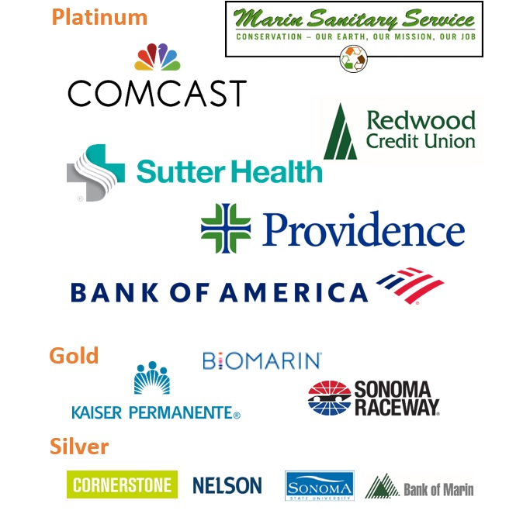

Members in the News

College of Marin to Hold 95th Annual Commencement and Transfer Recognition Ceremony In Person
College of Marin (COM) will be holding its annual Commencement and Transfer Recognition Ceremony in person this year, after two years of celebrating the event virtually because of the pandemic.

Bank of Marin Makes Donation to Santa Rosa City Schools
Bank of Marin is the newest partner with Santa Rosa City Schools. They presented them with a substantial investment, sharing their vision of providing equitable enrichment opportunities for students most in need.

Basin Street Properties Welcomes Guardian Angel Home Care to Stony Point Campus
Basin Street Properties, a prominent real estate investment, development, and management firm, is pleased to announce Guardian Angel Home Care has signed a lease at Stony Point Campus, premier office park in Santa Rosa, known for its unique campus-like environment.

BioMarin, Ultragenyx, and Other Biotechnology Companies May be Getting Campus Expansion in Novato
Novato is looking to augment its status as a North Bay biotechnology hub under a proposal that could double the footprint of its life sciences campus near Bel Marin Keys.

TekTailor Participates in the Free Fix-It Fair
A woman with a wobbly lamp said the waste bin might be the best place for it, but she wanted appliance repairman Farid Asef to take a look just in case.

The LIME Foundation’s Believe in the Dream Event Announced!
Join The LIME Foundation on Thursday, September 8, 2022, for a wonderful night!

Northern California Public Media Honored as One of the Edward R. Murrow Award Winners
In the radio large market category, the California Newsroom won the award for Continuing Coverage for the story Bankrupt.

Northern California Public Media’s Announcement of Election of New Officers
The Independent Public Television Station Association announces the election of new officers.

Marin Sonoma Impact Ventures Bets on Local Startups
A business venture with a dual goal of helping startups in Marin and Sonoma counties with networking and financing needs has been gaining momentum since launching at the height of the pandemic.

Burbank Housing Starting Construction at the Former Journey’s End Mobile Home Park Location
Construction underway at the former journey’s end mobile home park destroyed by the 2017 Tubbs Fire.

Sonoma County Winegrowers’ Karissa Kruse is Farming for the Future
Have you ever wondered how the farm of the future will look? Karissa Kruse, President of Sonoma County Winegrowers, will be sharing her insights on improving climate adaptation best practices by leveraging the latest innovation and technology at the Future Drinks Expo 2022.

Cornerstone Properties Working on Housing and Child Care in New Downtown Santa Rosa Development
Cornerstone Properties, a North Bay property owner, is developing a landmark housing project in Santa Rosa’s downtown core at 566 Ross Street and has announced a significant community benefit as a component of the development.
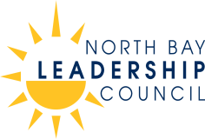

Who We Are
Over thirty years ago, business leaders founded the North Bay Leadership Council on a simple premise: We can accomplish more by working together. Today, the Council includes 54 leading employers in the North Bay. Our members represent a wide variety of businesses, non-profits and educational institutions, with a workforce in excess of 25,000. As business and civic leaders, our goal is to promote sound public policy, innovation and sustainability to make our region a better place to live and work. For more information: Call 707.283.0028 / E-mail info@northbayleadership.org
www.northbayleadership.org

