In This Issue
POLICY WATCH – February 2022

- Show Us the Receipts: Little More Than Half of U.S. Companies Disclose Their DEI Data
- Portrait of Sonoma Reveals Inequities
- 5 ways to start being a better ally for your black coworkers
- Women, Especially Women of Color, Are Not Rejoining the Labor Force in Sizeable Numbers
- What Else Would Help our Economy and our Democracy? Improving Adult Literacy
- Members in the News

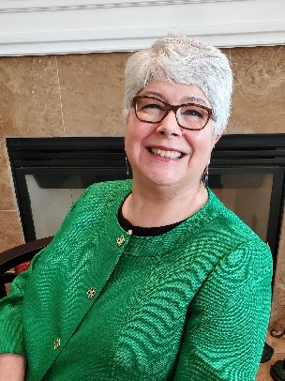
Barack Obama said, “Our responsibility as citizens is to address the inequalities and injustices that linger, and we must secure our birthright freedoms for all people. As we mark the 46th year of National African American History Month, let us reflect on the sacrifices and contributions made by generations of African Americans, and let us resolve to continue our march toward a day when every person knows the unalienable rights to life, liberty, and the pursuit of happiness.” In this issue, we look at the challenges of addressing those inequalities and injustices.

New data from the Portrait of Sonoma show we have gaps to close, some of those gaps having widened since the last report. We also look at companies keeping their promises on investing in DEI programs, and how women, especially women of color, are not participating in the workforce like pre-pandemic. And I hope you find how to be an ally to black coworkers helpful as we strive to do better individually.

There are many challenges ahead. Martin Luther King, Jr. reminded us that, “the arc of the moral universe is long, but it bends toward justice.” May we soon see justice prevail here and throughout the world.

Best,

Cynthia Murray

Show Us the Receipts: Little More Than Half of U.S. Companies Disclose Their DEI Data

In Show Us the Receipts: Little More Than Half of U.S. Companies Disclose Their DEI Data by Leon Kaye (Triple Pundit, Link), We learn that “In the weeks following the murder of George Floyd in May 2020, many companies said they would ‘stand by’ the Black community and pledged to ramp up their DEI (diversity, equity and inclusion) hiring efforts. But as time went on, ongoing evidence suggested that companies have curbed such work — one factor driving the ‘Great Resignation.’ The message many Black Americans have received is that if they are going to experience true social change, such messages from large organizations rang hollow, so they need to take on such challenges on their own.”

Kaye says, “Almost two years after those promises were made, our friends at Just Capital recently released their own research to gauge the current state of DEI data and disclosure. The results are mixed: On one hand, companies are more transparent than they were in 2021, but the U.S. public believes companies aren’t matching their deeds with actions. Bottom line: People of color are still waiting to be shown the receipts for the $50 billion that companies say that they’ve committed to DEI pledges.”

“So, where’s the progress?” asks Kaye. “Just Capital’s researchers found that based on the most recent data, 55 percent of companies in the Russell 1,000 disclosed some form of DEI data as of September 2021. That’s up significantly from 32 percent in January 2021. Meanwhile, in September of last year, 11 percent of these companies released their EEO-1 Reports or intersectional data, both of which Just Capital describes as the ‘gold standard’ in demographic reporting. That’s a jump from 4 percent a year earlier.” That’s progress but we have a way to go.

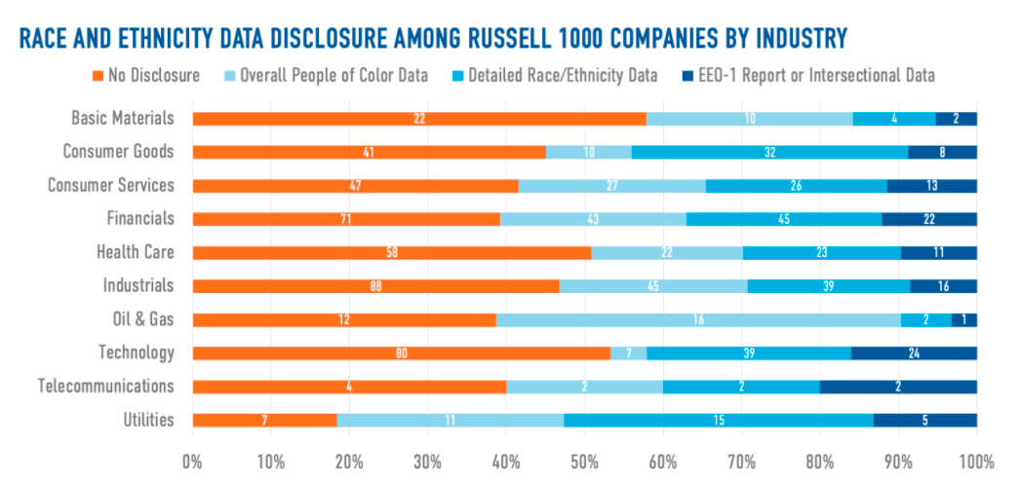

Kaye agrees. He says, “The promising news: A majority of companies in all but two broad industries – Basic Materials and Technology – report some type of workforce race and ethnicity data. Yes, those are steps forward, but as Just Capital sums up the efforts, ‘The data exists, it’s just a matter of sharing it publicly.’”

“As far as industries that are moving forward faster on such disclosures, they include the utilities, oil and gas, and the financial sector — the latter two especially when it comes to the public release of their EEO-1 or intersectional data reports,” says Kaye. “The financial industry in particular has had the fastest growth in disclosure rates, according to Just Capital’s survey. Laggards? Basic materials (as in companies that develop and process raw materials), technology, healthcare, industrials and consumer goods still have some catching up to do.”

Kaye says, “Even if companies don’t believe they have a moral or ethical obligation to do more to ensure everyone has a fair shot in building a career within the private sector, there are pragmatic reasons for pushing ahead such efforts — for example, the U.S. Securities and Exchange Commission (SEC) is heavily leaning toward that direction, as is Nasdaq. And, as we’ve regularly covered here on TriplePundit, there is an economic case for building a company that looks like the America of the 2020s.”

“Disclosing workforce and board demographics is an important step for companies to jumpstart or even refine their DEI initiatives. By doing so, they provide a baseline to track progress and a method to hold themselves accountable to improving diverse representation,” wrote Just Capital’s Kavya Vaghul, lead author of the report. “And, as the rise in calls for transparency has shown, they’re elements stakeholders are increasingly looking for from corporate America.”

Making equity a cornerstone of organizational values is not only needed, it brings rewards to terms of better employee retention and attraction, customer loyalty and productivity.

Portrait of Sonoma Reveals Inequities

The recently released Portrait of Sonoma has revealed where we need to do more work to have equity. Writing in 2021 Portrait of Sonoma County: Well-being study finds new successes, ongoing challenges along race, ethnicity, gender and geographic lines (Link), Nashelly Chavez says, Since the 2014 Portrait of Sonoma County was released, local residents’ median earnings have increased by about $7,000 and life expectancy rose by 1.2 years to 82.2 years. The rate of Sonoma County adults who are at least 25 years old and who hold bachelor’s degrees also increased 6 percentage points to 37.8%, the new 44-page report finds. But a breakdown of those well-being scores by race, ethnicity, gender and geography reveals disparities in several areas, the newest Portrait of Sonoma County shows.”

Chavez says, “Those issues are compounded, according to the report, by both long-standing and new challenges within the county, such as an affordable housing shortage, recurring wildfires and the COVID-19 pandemic. Those issues also disproportionately harm residents who are Black, Latino, or members of other racial minorities, inequities that are the result of local policies, the report adds.”

“The inequalities that exist today are not natural or inevitable, nor are they a product of chance; they are the result of policy decisions made by people in power,” the report states. “Different decisions, made through different, more inclusive decision-making processes, can lead to better, fairer outcomes.”

Pointing out the inequities, Chavez says, “While men and women in Sonoma County have similar well-being scores, despite women earning $11,500 less than men, metrics used to evaluate the health, wealth and education of local racial and ethnic groups vary, the portrait finds.

One of the most glaring changes is in the Black community. Chavez says, “The most notable change is in Sonoma County’s Black community, whose Human Development Index (HDI) score dipped to 3.99 in 2021, down from 4.68 in 2014.This group has a life expectancy of 71 years, which is 10 years shorter than any other racial and ethnic group in the county, according to 2021’s findings. In the 2014 report, the life expectancy of Black residents in Sonoma County was 77.7 years.”

She adds, “among local adults 25 years or older who have a college degree, only 32.1% of Black community members have undergraduate degrees compared to the county average of 37.8%.

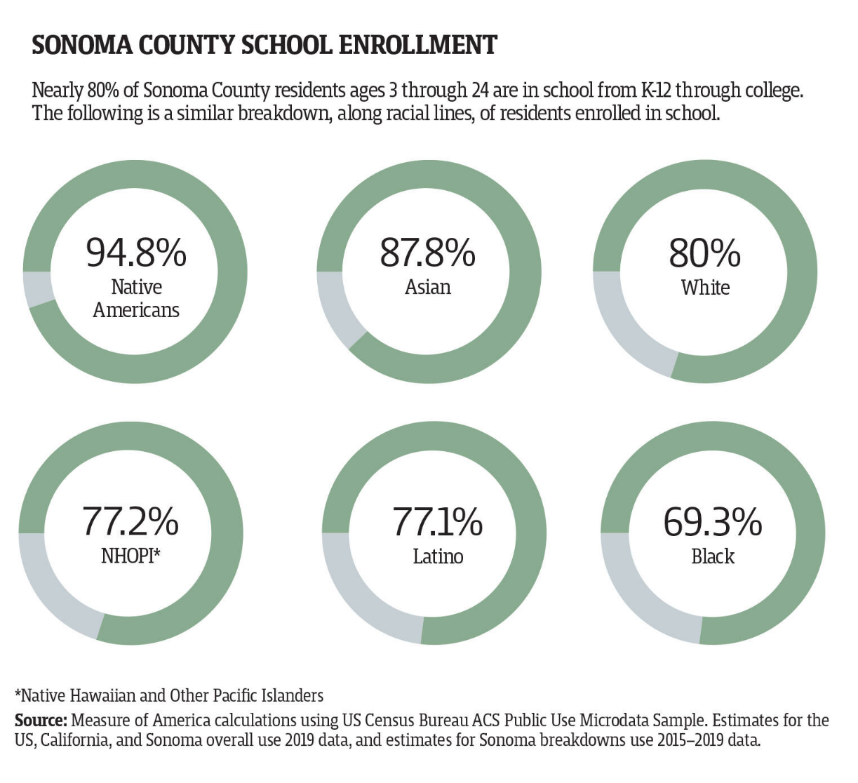
“Asian residents continued to have the highest HDI scores among the largest racial and ethnic groups locally, though their scores dropped from 7.10 to 6.86, the latest report finds. The well-being of white and Latino residents, overall, has improved slightly since the 2014 report. The data from the 2021 Portrait of Sonoma County noted, however, that Latino residents still have significantly lower educational attainment rates. More than a third of all Latino adults age 25 or older are without a high school diploma,” says Chavez.

Another key finding in the report is “While 52% of all renters in Sonoma County use 30% or more of their income to pay rent, that average is higher in some minority communities — 59% of Latino renters and 68% of Black renters use 30% or more of their income to pay for housing.”

To begin to address the inequities revealed in the report, the Board of Supervisors will consider how to invest roughly $35 million in federal COVID-19 relief funds allocated for community investments later this year.

5 Ways to Start Being a Better Ally for Your Black Coworkers

In 5 ways to start being a better ally for your black coworkers (Link), Courtney Connley provides great tips to help all of us do better in supporting our black co-workers and community. Connley’s 5 ways are illuminating and clear on how to improve our behavior to help all of us. Here are her 5 ways:

1. Recognize your privilege
Understanding your privilege as a white person is critical to understanding how race and racism can impact the trajectory of one person’s life.

Frances Kendall, author of Understanding White Privilege: Creating Pathways to Authentic Relationships Across Race, describes white privilege as “having greater access to power and resources than people of color [in the same situation] do.”

As a result of this unequal access to power and resources, black Americans can expect to earn up to $1 million less than white Americans over their lifetime, according to a recent study by McKinsey & Co. That same study also found that in 2016 the median wealth of a white family was 10 times the median wealth of a black family.

This racial wealth gap is linked to years of discrimination in housing, education, employment and the criminal justice system. When looking at housing, for example, data from the Urban Institute finds that real estate agents and rental housing providers recommend and show fewer homes and apartments to minorities than equally qualified whites.

When looking at the criminal justice system, data from the United States Sentencing Commission reports that black men who commit the same crime as white men are given prison sentences that are, on average, 20% longer. When examining the dynamics of police interactions, black people are more likely to be stopped by police at a traffic stop and street stop than white people, and police are twice as likely to threaten or use force against a black or Hispanic person than a white person, according to data from the Bureau of Justice Statistics.

In Robin DiAngelo’s book, White Fragility: Why It’s So Hard for White People to Talk About Racism, she explains how it is critical for white people to have uncomfortable conversations about race so that they can recognize their privilege and understand how they benefit from “a society that is deeply separate and unequal.”

With white people sitting at the majority of America’s leadership tables, DiAngelo writes that it’s imperative for them to understand how racism works because the “decisions made at those tables affect the lives of those not at the tables.”

“Exclusion by those at the table doesn’t depend on willful intent; we don’t have to intend to exclude for the results of our actions to be exclusion,” she explains. “While implicit bias is always at play because all humans have bias, inequity can simply occur through homogeneity; if I am not aware of the barriers you face, then I won’t see them, much less be motivated to remove them.”

2. Educate yourself
The real work of allyship comes in the form of educating yourself on the things you need to personally learn and unlearn in order to be a better advocate.

In addition to Kendall and DiAngelo’s books listed above, there are several other great pieces of literature that unpack systemic racism and white privilege including How to be an Antiracist by Ibram X. Kendi; Between the World and Me by Ta-Nehisi Coates; and Me and White Supremacy: Combat Racism, Change the World, and Become a Good Ancestor by Layla Saad.

In addition to these books, the National Museum of African American History & Culture just released a new online portal called “Talking About Race.” This portal, according to a press release, is “designed to help individuals, families and communities talk about racism, racial identity and the way these forces shape every aspect of society.” The portal includes online exercises, scholarly articles and more than 100 multimedia resources for individuals who are committed to racial equality.

3. Check in and speak up
During times like this when the news is filled with heavy headlines about black death, violence and protests, checking in with your black colleagues just to show that you care and are aware of what’s going on can make a difference.

“I think the most important part for our non-black employees, colleagues and leaders to do is to just say something,” career and leadership coach Kimberly Cummings tells CNBC Make It. “There’s this pressure right now to say the right thing, but honestly, there is not necessarily a right thing to say because everyone is processing the situation differently.”

Cummings says that a simple check-in to say, “I know you could potentially be going through a really hard time right now so if you need to take a day then take a day,” could really help. And she says leaders who are managing teams should reach out to all staff members, not just black employees, to show that they are aware of what’s going on and they have resources available for those in need.

“I think the silence is what’s deafening, and I think it’s what hurts the most in corporate America,” she says, while emphasizing that employees are watching what leaders are and aren’t speaking up about.

4. Understand that silence is complicit
Beyond addressing what’s happening in the news, it’s important that non-black colleagues and leaders are vocal when they witness instances of bias, racism and injustice in their immediate workplace and community.

For example, Cummings says, if you’re on a Zoom call at work where an insensitive comment is made or if you’re in an environment where the work of a black colleague is constantly overlooked, then you should not turn a blind eye to the situation.

“I think addressing it is the most important issue,” she says. “As we’re talking about everything that’s happening in the world right now, the common denominator is that there are issues that need to be addressed and spoken about openly and candidly and that also applies to the workplace.”

She emphasizes that now is not the time to sweep things under the rug and act like they aren’t happening. In fact, she says, the role of an ally is really about “speaking up when another group may not be able to.”

“I think in times like this, where everything is so tense, there is a heightened focus on the experience of a black person in work, outside of work and everything in their daily life,” she says. “So as an ally, if you see something and it makes you feel uncomfortable and you notice that it’s making your minority colleagues feel uncomfortable, then it is crucial for you to speak up and talk about how this behavior, this conversation, this action is inappropriate.”

Doing this, she says, “is where change is going to happen because silence is literally showing folks that what is happening is OK, it’s tolerated and it’s acceptable.”

5. Hire, promote and support black professionals
Speaking out against issues of racism and injustice can easily fall on deaf ears if you’re leading a company that does not prioritize hiring, promoting and supporting black workers.

In a report released last year from the Center for Talent Innovation titled “Being Black in Corporate America,” it was stated that roughly one in three black professionals aspire to hold executive positions at work and nearly two in three consider themselves to be “very ambitious” toward their career. Yet, despite this ambition, black professionals today hold just 3.2% of executive and senior management positions in corporate America and less than 1% of Fortune 500 CEO spots. Of the four black CEOs leading a Fortune 500 company today, none of them are women.

“It’s embarrassing because there are thousands of [black] people who are just as qualified or more qualified than I am who deserve the opportunity, but haven’t been given the opportunity,” Kenneth Chenault, former chairman and CEO of American Express, said in the report.

In a study released by researchers at Northwestern University, Harvard, and the Institute for Social Research in Norway, it was discovered that anti-black racism is still an issue in the hiring process today with white applicants receiving 36% more callbacks for jobs than equally qualifying African Americans.

Kenneth Frazier, who serves as the CEO of pharmaceutical company Merck, is one of Fortune 500′s few black CEOs. In an interview on CNBC’s “Squawk Box,” Frazier spoke openly about these inequalities and explained how George Floyd’s death personally impacts him as a black man. As a leader in corporate America, he called on all business leaders to step in and be a “unifying force” in creating opportunities and jobs for diverse professionals.

“I know for sure that what put my life on a different trajectory was that someone intervened to give me an opportunity, to close that opportunity gap,” he said. “And that opportunity gap is still there.”

We should all try to be a unifying force in creating opportunities and jobs for diverse professionals!

Women, Especially Women of Color, Are Not Rejoining the Labor Force in Sizeable Numbers

New research by the Bureau of Labor Statistics (BLS) show a continuing disturbing trend that women, especially women of color, are still not rejoining the workforce anywhere near the amount they were pre-pandemic. In 27 Times More Men Than Women Joined the Labor Force in January 2022 (Link), Jasmine Tucker reports, “The most recent Bureau of Labor Statistics (BLS) monthly jobs report shows that just 39,000 women ages 20 and over joined the labor force in January 2022, meaning they are newly working or looking for work. Even with these modest gains, there were still nearly 1.1 million fewer women in the labor force in January 2022 compared to February 2020. Meanwhile men ages 20 and over joined the labor force last month in massive numbers, with over 1 million more men newly working or looking for work. This means men have now recouped all their labor force losses since February 2020. The sharp contract between the number of men and women joining the labor force last month likely reflects the uneven caregiving responsibilities men and women have taken on in the wake of the Omicron variant which caused continued school and child care disruptions last month.”

Tucker says “The economy gained 467,000 jobs in January 2022. Women gained just 40.3% of these jobs, or 188,000, while men gained 279,000 jobs last month. Despite these gains, it would take six months of growth at January’s level to gain back the nearly 2.9 million jobs the economy has lost since February 2020 and it would take women nearly 10 months of growth at January’s level to gain back the over 1.8 million jobs they have lost since February 2020.”

Tucker shares disheartening statistics:
Women gained 188,000 jobs last month but are still short over 1.8 million jobs since February 2020.
- Since February 2020, the economy has experienced a net loss of nearly 2.9 million jobs; women account for 63.3% of those losses.
- The leisure and hospitality sector gained 151,000 jobs in January 2022. Women gained 52,000 jobs in this sector, or 34.4% of the jobs added. Women make up 52.7% of the leisure and hospitality workforce.
- The retail trade sector gained 61,400 jobs in January. Women gained 45,000 jobs, or 73.3% of the jobs added. Women make up 48.8% of the retail trade workforce.
- The government sector gained 23,000 jobs in January. Women gained 26,000 jobs while men lost 3,000. Women make up 58.0% of the government workforce.
- The education and health services sector gained 29,000 jobs in January. Men made up 100% of these gains, while women lost 17,000 jobs. Women make up 76.7% of the education and health services workforce.
- The child care sector gained 5,600 jobs last month. The net number of child care jobs lost since February 2020 is 131,200. The child care sector has lost nearly 1 in 8 jobs (12.4%) since the start of the crisis.

The overall unemployment rate masks higher rates for Black women, Latinas, and other demographic groups.

- Tucker says, “The unemployment rate for women ages 20 and over remained unchanged at 3.6% last month. In comparison, the unemployment rate for men ages 20 and over increased from 3.6% in December to 3.8% in January. This was driven largely by massive numbers of men entering the labor force last month.” And shares more alarming statistics:

- Nearly 1 in 17 Black women ages 20 and over (5.8%) were unemployed in January 2022, down from 6.2% in December 2021. About 1 in 14 Black men ages 20 and over (7.1%) were unemployed in January 2022, up from 7.0% in December 2021.
- Nearly 1 in 20 Latinas ages 20 and over (4.9%) were unemployed in January 2022, unchanged from December 2021.
- About 1 in 31 Asian women ages 20 and over (3.2%) were unemployed in January 2022, down from 3.3% in December 2021.
- By comparison, the unemployment rate for white men ages 20 and over was 3.2% in January 2022, up from 3.0% in December 2021.
- Over 1 in 13 women with disabilities (7.9%) were unemployed in January 2022, down from 8.0% in December 2021.

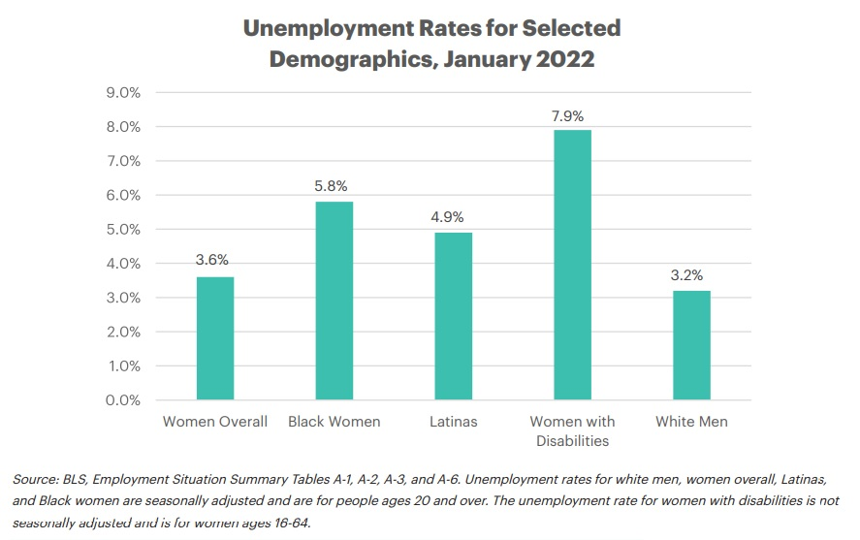
Many unemployed women have been out of work for 6 months or longer.

“In January 2022, over 1 in 4 unemployed women ages 20 and over (26.3%) had been out of work for six months or longer,” says Tucker. “Among unemployed women ages 16 and over, 24.1% had been out of work for six months or longer, including 29.4% of unemployed Asian women, 29.0% of unemployed Black women, and 22.1% of unemployed Latinas. Additionally, in January 2022, over 1 in 6 unemployed women ages 16 and over (17.1%) had been out of work for a year or longer.”

If the nearly 1.1 million women who have left the labor force since February 2020 were counted among the unemployed, women’s unemployment would have been 5.0% last month.

And again, it is women of color who are being impacted the most. Tucker says, “Since February 2020, 168,000 Black women have left the labor force, along with 61,000 Latinas. If these women were counted as unemployed, the unemployment rate for Black women in January 2022 would have been 7.3% instead of 5.8%, and Latinas’ unemployment rate would have been 5.4% instead of 4.9%.”

Paying attention to the numbers cited above about how women of color are being disproportionately impacted by the pandemic is important if we are to move to a more equitable future. We must remove the barriers to women working, starting with improving child care access and affordability. And a more equitable future means a better economy and a stronger community.

What Else Would Help our Economy and our Democracy? Improving Adult Literacy

Forbes’ reporter, Michael T. Nietzel, points out the high cost of low literacy in Low Literacy Levels Among U.S. Adults Could Be Costing The Economy $2.2 Trillion A Year (Link).

And if we are observant of the decline in knowledge and respect for civics, history and science, low literacy is hurting more than our economy. Nietzel reports on a study by Gallup on behalf of the Barbara Bush Foundation for Family Literacy finds that low levels of adult literacy could be costing the U.S. as much $2.2 trillion a year.

He says, “According to the U.S. Department of Education, 54% of U.S. adults 16-74 years old - about 130 million people - lack proficiency in literacy, reading below the equivalent of a sixth-grade level. That’s a shocking number for several reasons, and its dollars and cents implications are enormous because literacy is correlated with several important outcomes such as personal income, employment levels, health, and overall economic growth.”

Commenting on the significance of the study, British A. Robinson, president and CEO of the Barbara Bush Foundation, said, “America’s low literacy crisis is largely ignored, historically underfunded and woefully under-researched, despite being one of the great solvable problems of our time. We’re proud to enrich the collective knowledge base with this first-of-its-kind study, documenting literacy’s key role in equity and economic mobility in families, communities and our nation as a whole.”

Nietzel says, “The new research by Gallup attempts to estimate the gains in GDP that could result from improving adult literacy rates for the nation as a whole as well as in the individual states and major metropolitan areas. The study, entitled “Assessing the Economic Gains of Eradicating Illiteracy Nationally and Regionally in the United States,” under the direction of lead author Dr. Jonathan Rothwell, Gallup’s principal economist, relied on an international assessment of adult skills called the Program for the International Assessment of Adult Competencies (PIAAC) that classifies literacy into several levels. The Department of Education used those results to create and publish estimated literacy levels for every U.S. county.”

It stands out that Robinson says this is one of the great solvable problems of our time. Locally, we have great organizations working to do just that:

The Literacyworks Center (https://www.literacyworkscenter.org/) is to assist underserved, below-basic-skills adult students in solving the many educational, personal and logistical challenges they must face to stay in school and succeed in work. The Center is providing advising, mentoring and scholarship support (through the Adult Literacy Awards) that help break persistence barriers to school completion such as transportation, childcare and tuition. As a further service, The Center is also dedicated to creating a stronger pipeline between qualified students seeking good jobs and local employers.

Sonoma County Library Adult Literacy Program (https://sonomalibrary.org/locations/adult-literacy-program) provides one-to-one tutoring for English speaking adults who wish to improve their reading and writing skills. Our program is learner-centered – we work with the adult learner in accomplishing his/her goals.

Members in the News

Keysight Introduces Radar Scene Emulator Solution to Accelerate Path to Full Vehicle Autonomy
Keysight Technologies, Inc. (NYSE: KEYS), a leading technology company that delivers advanced design and validation solutions to help accelerate innovation to connect and secure the world, has introduced the Radar Scene Emulator, which enables automakers to lab test complex, real-world driving scenarios, accelerating the overall speed of test.

Keysight Technologies Q1 earnings rise 33%
Keysight Technologies Inc. (NYSE: KEYS) on Thursday reported fiscal first-quarter profit of $229 million, up 33% from a year before.

Bank of America’s Jason Foster Celebrates 25 Years with the Company
Congratulations to Jason Foster and thank you for all of your years of great work!

Exchange Bank Promotes Executive to Lead Retail Banking
Rick Mossi has been promoted by Exchange Bank to senior vice president of retail banking.

Strata Clean Energy 2 Large Battery Projects in Sonoma and Solano
Two battery storage projects in Solano and Sonoma counties large enough to power hundreds of thousands of homes are part of a big bet California is making to store power generated by alternative sources and meet its goal of a zero-emissions energy grid.

Basin Street Properties Brings Culture, Collaboration and Carbonation to Oak Valley Business Center
In the spirit of bringing teams back together in the office and in activities outside of the office, Basin Street Properties is excited to announce the promotion of a Team Building Activities Fund for new tenants at select properties across its portfolio.

Keysight Technologies’ Hamish Gray Honored with Spark Award
Congratulations Hamish Gray for your innovation and leadership!

The Lime Foundation’s Letitia Hanke Featured in the Upcoming Book Self-Made Boss
Letitia Hanke is a leader and self-made success story.

The LIME Foundation’s New President Announced
The new President of The LIME Foundation is Marco Guerra.

Sonoma County Winegrowers Partner with Ford to Give Farms Electric Pickups
Ford Motor Co. on Jan. 26 announced the launch of a pilot program that will equip winegrowers in Northern California with electric pickup trucks, cargo vans and software services in a bid to boost EV and technology adoption among farmers and other commercial customers.

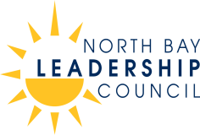

Who We Are
Over thirty years ago, business leaders founded the North Bay Leadership Council on a simple premise: We can accomplish more by working together. Today, the Council includes 54 leading employers in the North Bay. Our members represent a wide variety of businesses, non-profits and educational institutions, with a workforce in excess of 25,000. As business and civic leaders, our goal is to promote sound public policy, innovation and sustainability to make our region a better place to live and work. For more information: Call 707.283.0028 / E-mail info@northbayleadership.org
www.northbayleadership.org

